- Difference between c and c++?
- C is a procedural programming language, whereas C++ is a multi-paradigm language that supports procedural programming as well as other programming philosophies
- C does not support object-oriented programming concepts like polymorphism and encapsulation, unlike C++
- C++ supports several new features like namespace, reference variable functionality, operator overloading, and function overloading

- Object in C++
Objects are real-world entities that have a state (some kind of data) and behavior (functionality). Together, related objects make up a class

- Class Vs Structures
Class and structure (or struct) are virtually the same in C++, except for the default accessibility setting of member variables and methods. In a class, they are set as private; in a structure, they are set as public.

- Volatile
The volatile keyword is a qualifier that can be applied to a variable to inform the compiler that the variable value may change at any time. The main reason for using volatile is to prevent optimizations on objects occurring in the source code.

- Memory management in C++
C++ supports dynamic memory, which means memory must be managed manually by the user rather than automatically with a garbage collector feature. Memory is allocated and deallocated dynamically using the ‘new’ and ‘delete’ operators respectively.

- Data types
Data Type | Typical Size | Description
char | 1 byte | single character
bool | 1 byte | true/false
short | 2 bytes | small integer
int | 4 bytes | integer
long | 4 or 8 bytes | large integer
long long | 8 bytes | very large integer
float | 4 bytes | decimal number
double | 8 bytes | more precise decimal
long double | 12 / 16 bytes | extra precision
std::string | implementation dependent (commonly 24–32 bytes object size) | string object

- Auto
The auto keyword informs the compiler to use the initialization expression of a declared variable to deduce its type. It can be used instead of variable types and is generally considered a more robust, efficient alternative with superior performance.

- Shallow copy and deep copy
Shallow Copy → copies the pointer address only
Deep Copy → copies actual data into new memory
Test t1(10);
Test t2 = t1; // shallow copy

// Deep Copy Constructor //Creates another data storage
Test(const Test& other)
{
data = new int(*other.data);
}
- Pass by value Vs pass by reference
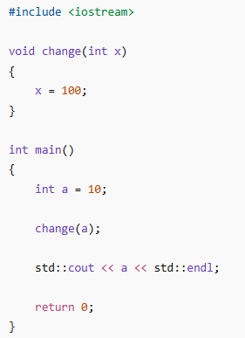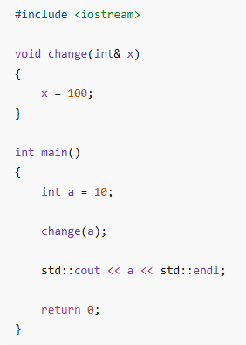
Output – 10 Output – 100

- RAII
RAII is an idiom that stands for ‘Resource Acquisition Is Initialization’. It ensures that resources are correctly released at the end of a scope, even if an exception occurs. The purpose of RAII is to prevent resource leaks and provide a basic exception safety guarantee.

- Pointer vs ref
int a = 10;

int* ptr = &a; ptr ----> address of a

int a = 10;

int& ref = a; //ref and a are same variable

- Stack vs heap
int* ptr = new int(10);
stack:
ptr ---->

heap:
10

- Smart pointers
std::unique_ptr
std::unique_ptr<int> ptr = std::make_unique<int>(10); //memory automatically deleted
unique pointer ownership transfer -
std::unique_ptr<int> p2 = std::move(p1);
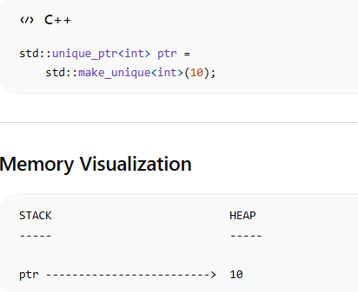
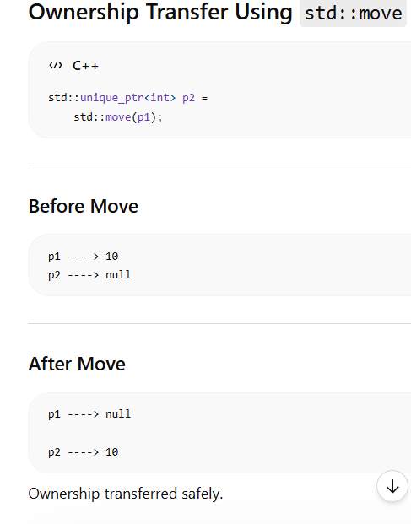

std::shared_ptr
std::shared_ptr<int> p1 = std::make_shared<int>(100);
std::shared_ptr<int> p2 = p1;
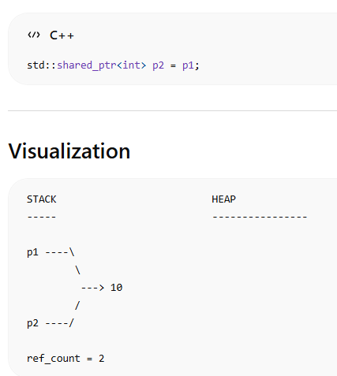

- rvalue vs lvalue
Type | Meaning
lvalue | has memory/address
rvalue | temporary value
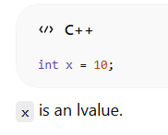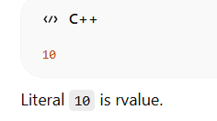

- what are std::move and std::forward
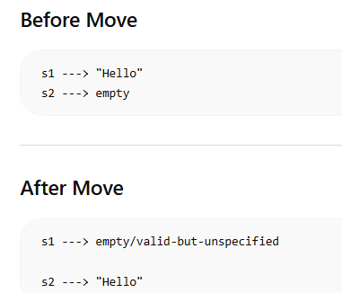

Std::forward
“If original thing was temporary, keep it temporary.”
“If original thing was normal object, keep it normal.”

- Template
A template allows writing generic code.
Meaning:
- one function/class
- works with multiple data types Without rewriting code again and again.
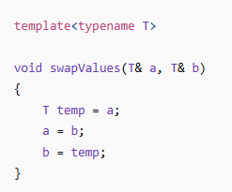
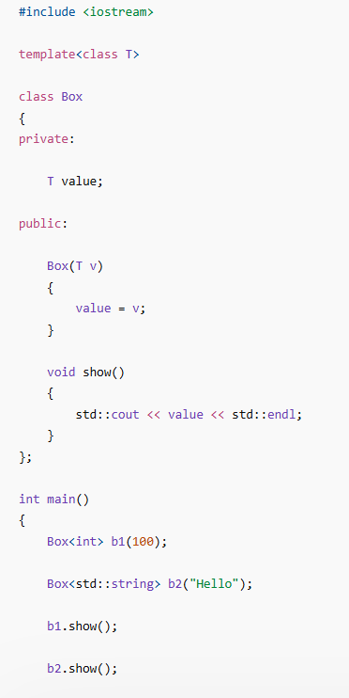

- Ways to access private fields of some class?
Friend function and friend class

- Can a class inherit multiple classes?
Yes multiple inheritance

- Can an exception be thrown in constructor / destructor? How to prevent that?
Try catch or noexcept

- Why do we need virtual destructor?
derived destructor may not run
resources may leak
undefined behavior occurs

- No.
Constructors CANNOT be virtual in C++.
Compile time error

- int getX() const
means, inside the function object data cannot be modified

- How to protect object from copying?
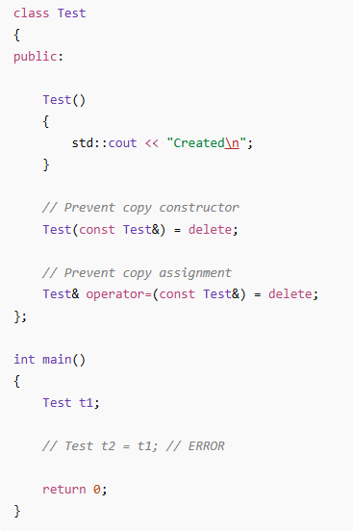

- Difference between vector and list?

vector
Uses dynamic array.
[10][20][30][40]
Continuous memory. Random access vector fast.

list
Uses doubly linked list.
10 <-> 20 <-> 30 <-> 40
Each node stores:
data
next pointer
previous pointer

